Marketing strategy

1. 4C’s
   * Context

* Competition
* Customer
* Company (capabilities)

1. Objectives
2. Segmentation/Targeting/Positioning
3. Marketing Review
4. Marketing Objectives
5. Marketing plan/Mix
6. Control/contingencies

4C’s

* Macro Trends -Context (PESTED)
  + Political
  + Economic
  + Socio-cultural
  + Technological
  + Physical Environment
  + Demographic
* Competition
  + Porter five forces; in terms of High, medium, low threat and favourable / unfavourable industry
    - Rivalry amongst present competitors
    - Threat of new entrants
    - Bargaining Powerof Buyer
    - Bargaining power of supplier
    - Threat of substitutes
  + Driving forces;
    - Change in growth rate, key segments, government regulations, cost efficiencies.
    - Rate of diffusion of proprietary.
* Customer;
  + Use descriptors like demographic, geographic, behavioral (life style, family, industrial goods/buying center), Distinguish between B2B & B2C consumer behaviour – ex. high involvement purchase, Age 45, income 45000$,,,
* Capabilities; (SWOT)
  + Strength; inside the company (established customer, R&D, Engineering)
  + Weakness; inside the company (overestimate, underestimate, poor R&D,,,,)
  + Opportunities; outside (untapped segments, potential, Switching cost,,,)
  + Threat; outside (substitutes products, new entrants,,,)

Objectives;

* Corporate level
  + Ansoff Matrix

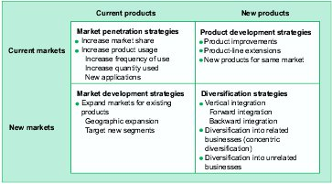

* BU level
  + Miles and Snow typology
    - Prospector
    - Analyzer
    - Defender
  + Porter’s generic competitive matrix



* Marketing level
  + PLC



* + - Introduction
    - Growth
    - Shakeout
    - Mature
    - Decline

At the end is about where to compete and how to win; selection will be differentiated analyser, growth market…

* Segmentation/Targeting/Positioning STP
  + Segmentation; divides the market into subset of customer with similar needs. Use descriptors, Macro and Micro segmentation used for industrial goods, Marketing research is must. (Geogra., Demo, GeoDemo ,Behav.)
    - Macro; firm’s demographic; size, age of the firm
    - Micro; People in buying center
  + Targeting; select your segment and allocate your resources
    - Targeting based on Market attractiveness and competitive position,
      1. Choose Criteria to measure attractiveness (factors)
      2. weight each factor depending on its importance
      3. rate each segments on each factor current position
      4. project future position for each segment
      5. choose segment to terget.

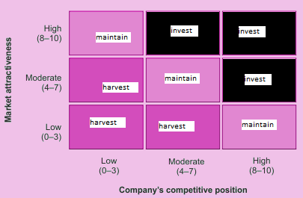

* + - Select a strategy; niche, growth, mass.
  + Positioning; product place in customer mind
    - Attributes, physical, perceptual, product/service quality tips.

1. Identify relevant set of Competitive Products
2. Identify determinant attributes
3. Collect data about customer perception
4. Analyse the current position of products (positioning Grid)
5. determine customer most preferred set of attributes
6. Write positioning statement (Tgt Mkt, Brand, Product categ, benefit)

* Review;
  + Market is homogenous, heterogonous, growth in place and mature in other,,,,
* Objectives; select marketing strategy
  + New market;
    - Mass market penetration; product with quickly adaptation and hard to copy technology
    - Niche penetration; small pioneer, product with quickly adaptation and easy to copy technology
    - Skimming and early withdrawal; small pioneer, competition is inevitable, product with slowly adaptation and easy to copy technology
  + Growth market
    - Leader; usually combine 2 ST
      * Fortress; strengthen your position
      * Flanker; create another brand
      * Confrontation; meet or beat your competitor
      * Expansion; line extension; get new customers
      * Contraction; leave slow growth segment and focus on faster one
    - Follower; usually combine 2 ST
      * Frontal attack; Steal current customer of a leader
      * Leapfrog; product/service superiority
      * Flanking; create another brand/leader not attackable
      * Encirclement; market heterogeneous, leader not attackable
      * guerrilla attack; surprise raids against the leader
  + Mature
    - Maintaining Current MS:
      * Fortress Strategy
      * Flanker Strategy
      * Niche Strategy
    - Expanding Volume Growth:
      * Increased penetration; convert non user to users
      * Extend use; enhance the frequency
      * Market Expansion; target underdeveloped areas
  + Decline
    - Harvesting; get maximum profit
    - Maintenance; maintain the market share; future hard to predict
    - Profitable survivor; increase market share, acquire the competitors
    - Niche; one or more segments not yet declined.
* Marketing plan 4P’s
  + Price; intensive, less intensive
    - Cost-oriented; customary,,,,
  + Product
    - Quality tips
  + Place
    - Channels to be used
  + Promotion
    - Advertising; pull
    - Sales Promotion;
      * Consumer promotion; pull
      * Trade promotion; push
    - Personal selling; Push
    - Public Relation; both Pull & Push
* Relevant control plans should be implemented to make sure the plan is on track
* Environmental trends should be monitored and contingency plans should be prepared.